- To create something from a file
kubectl create -f <file path> [it’ll create if resource doesn’t exist]
kubectl apply -f <file path> [ create if doesn’t exist; update if exists ]
- To edit any resource live
kubectl edit <resource type> <resource name>
kubectl edit pod my-pod
- To see all the details of a resource along with events
kubectl describe <resource type> <resource name>
kubectl describe pod my-pod
- To see live resource configuration in yaml format
kubectl get <resource type> <resource name> -o yaml
kubectl get pod my-pod -o yaml
- Too see all the things of the available resources
kubectl get <resource type> <resource name> -o wide
- To get a yaml configuration file of any resource to start with,
--dry-run=client -o yaml append this in the imperative commands.
kubectl create deployment my-dep --image=nginx --dry-run=client -o yaml
- Pod
  - To create a pod (“v1”)
kubectl run <pod name> --image=<image name>
kubectl run my-pod --image=nginx
  - Whatever ports you write inside containers (inside pods) are not exposed, that is just used for user’s docs or to search pods a/c to ports.
The traffic reaches to a specific port of a container with Service only.
  - If a pod contains multiple containers,
each container: same IP, different ports [ because IP is assigned to Pod ]
- ReplicaSet
  - ReplicaSet (“apps/v1”) and ReplicationController (“v1”) cannot be created with imperative commands.
  - ReplicaSet contains spec.selector field, which ReplicationController doesn’t have.
  - Selector contains matchLabels or matchExpressions.
  - template (pod) should contain same or more labels present in selector.
Selector’s labels work with AND rule, not OR. All the labels must be present in the pods to be selected.
  - To scale replica set:
kubectl scale --replicas=<replica count> replicaset <replicaset name>
kubectl scale --replicas=4 replicaset my-rs
- Deployment
  - Deployment can be created with Imperative way because Kubernetes auto-fill the required complex fields like template, labels, selectors.
kubectl create deployment <deployment name> --image=<image name> --replicas=<replica count>
  - It provide pull, upgrade, rolling update (or) recreate, rollback (undo), pause (rollout pause), resume (rollout resume) over ReplicaSet.
  - It create new versions, and scales down old ReplicaSet gradually and scales up new ReplicaSet gradually.
  - maxUnavailable (maximum allowed unavailable pods. Percentage or count), maxSurge (maximum allowed available pods. Percentage or count)
[ scale up of new pods & scale down of old pods happens w.r.t. maxUnavailable & maxSurge ]
  - To see rollout status,
kubectl rollout status deployment <deployment name>
To see rollout history,
kubectl rollout history deployment <deployment name>
[ for this --record has to be provided; but its deprecated ]
To undo the deployment
kubectl rollout undo deployment <deployment name>
  - Deployment = ReplicaSet + [rollout, rollback, versioning(revisions), rollout strategy (Recreate, RollingUpdate), Pause, Resume]
- Deployment Strategy
  - RollingUpdate: gradually remove old pods and create new pods.
  - Recreate: remove all old pods and create new pods.
- Service
  - Required to communicate with the pods.
[ Pod’s IP can be used; but shouldn’t because Pods might get re-created ]
  - External to Pod: NodePort
Pod to Pod: ClusterIP (NodePort can also be used; but not preferred)
Load Balancing: LoadBalancer [ works in cloud based clusters ]
  - type:NodePort
ports: [{ nodePort: x, port: y, targetPort: z }, { .. }, ..]
port means service’s port
in here, whatever port you assign for service, it doesn’t matter because it is there only to connect nodePort to targetPort (pod’s port).
  - type: ClusterIP
ports: [{ port: x, targetPort: y }, { .. }, ..]
  - For inter-pod communication
<service name>:<service port>
service -> name, selector; pod: labels; <-- these are important
  - selector doesn’t contain matchLabels, matchExpressions.
Direct key:value pairs (labels) to select the target pods.
  - Service’s redirection to Pod is cluster level. So service’s and pod’s host nodes might be different.
- kubeadm tool can be used to create a cluster and configure multiple nodes (control plane & worker nodes). it generates the required certificates and all.
https://github.com/kodekloudhub/certified-kubernetes-administrator-course/tree/master/kubeadm-clusters/generic
- cgroup (Control Group)
  - Used to enforce limits by Kernel.
  - mount | grep cgroup : to see the mounted path (/sys/fs/cgroup)
cgroup2 for modern systems; cgroup for older systems;
  - Files & Directories inside cgroup are handled by ?
    - all files : Kernel
    - directories of format cgroup.*, cpu.*, memory.*, io.* : Kernel
    - directories of format .slice, .scope, .service, .mount : systemd
    - other directories (docker, kubepods ..etc): respective owners
  - system.slice contains containerd.service, it means container runtime (containerd) is managed by systemd itself.
In case of separately handled, both will not get to know each other’s usage and request for more resources; at the end kernel will take action and stop some resources which might be important.
  - Owners writes into the respective files, Kernel enforces limits.
- Internals of kubectl apply
  - 3 configs are there:
config file (static yaml configuration file used to create a resource)
live config file (configuration file of the running resource; kubectl get <resource type> <resource name> -o yaml )
last applied config (latest config applied in declarative way) [its in JSON format ]
  - Running resource updated with:
    - imperative command (or) kubectl edit command: live config is updated, last applied config will remain same
    - Declarative way (kubectl apply) : live applied config will be updated, config file will be updated of-course.
  - Configs updation:
If a field is there in live config (ex: an extra level was added using kubectl edit command) but not in both config file and last applied config then field will remain as it is.
If a field is there in either config file or last applied config or both then that field will be updated (doesn’t matter if that field is there in live config or not)
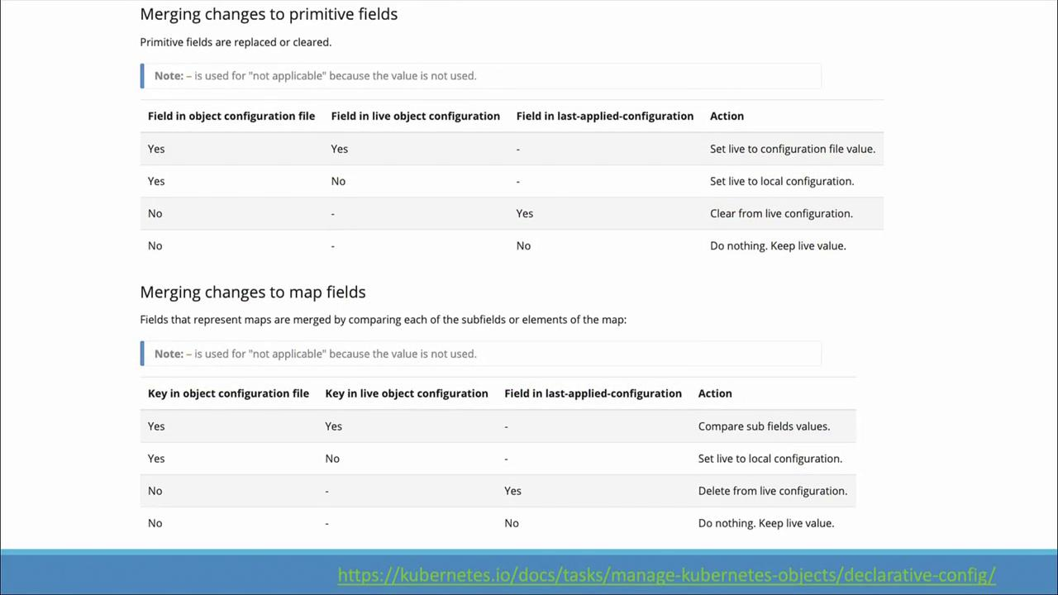
- namespace
  - Namespace defines a logical boundary where resources can be present.
  - Same named resources cannot stay inside a single namespace; but can be present in different namespaces.
  - Ex: dev, prod, ..etc namespaces can be created.
  - To query/update resources in a specific namespace, use
-n <namespace name> (or) --namespace <namespace name>
kubectl get pods -n dev-namespace
  - In the yaml, metadata.namespace is the required field to set the namespace.
  - Clustered configured with kubeadm, contains kube-system namespace which contains control plane resources.
  - To access a service of another namespace
<service name>.<target namespace name>.svc.cluster.local
db-service.dev-namespace.svc.cluster.local
- ResourceQuota
  - Used to limit resources for namespace level.
  - 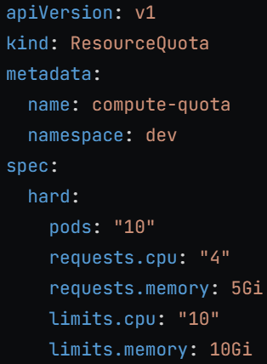

- F
- F
- F
- F
- F
- F
- F
- F
- F
- F

